**STEPS TO RUN SNAPDEAL IP PROJECT ON YOUR PC !**

1. **Download the file from the link which has been provided by me !**
2. **Put that file anywhere in your pc, i recommend you to put it on desktop**
3. **The file which you had downloaded would be in RAR !, so extract it by right-clicking it!( click on extract to snapdeal)**

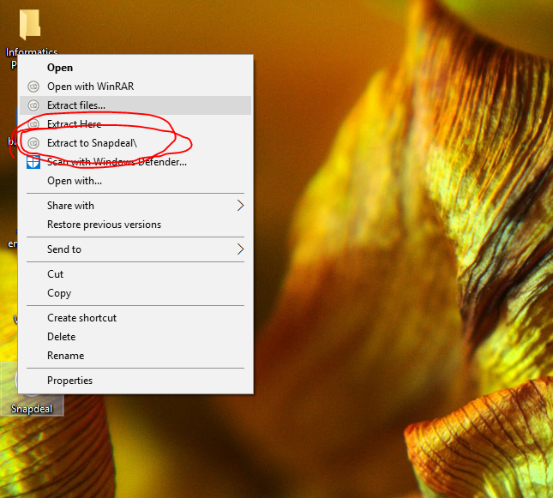

**4. Then open that extracted folder and then open SQL queries file !**

**5. PRESS CTRL+A to select all queries and then PRESS CTRL+C to copy !!**

**6. Then open MySql then paste all the queries( DO NOT USE CTRL+V TO PASTE, right-click and then click paste) there !**

**7. NOTE: after pasting the above sql queries, your sql password will change to “ 12345 ”**

**OK NOW WAY TO DESIGN AND CODE**

**8. Open netbeans IDE !**

**9. Click on file tab and then click on open project**

**10. Then browse your extracted SNAPDEAL folder on desktop !**

**11. Voila ! YOU HAVE DONE IT !!**

**EXTRA !!!**

**If some error comes like of import rs2xml, then don’t worry , just simply click on resolve and then browse to extracted snapdeal folder and click on rs2xml !! THAT’s SIMPLE !!!**

**RIGHT CLICK ON SNAPDEAL PROJECT NAME AND CLICK ON RUN !**

**Done**

**IF ANY MORE PROBLEM THEN FEEL FREE TO CONTACT ME ON MY EMAIL** [**rohanpatel7777777@gmail.com**](mailto:rohanpatel7777777@gmail.com)

**THANK YOU !**